**Calculating two-sided critical values for Tukey’s test and Dunnett’s test**

**Tukey’s range test for all pairwise differences**

<https://www.real-statistics.com/one-way-analysis-of-variance-anova/unplanned-comparisons/tukey-hsd/>

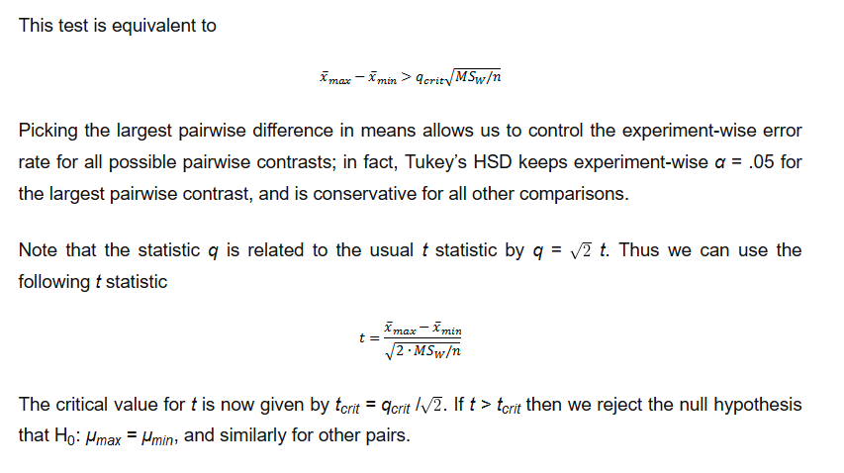

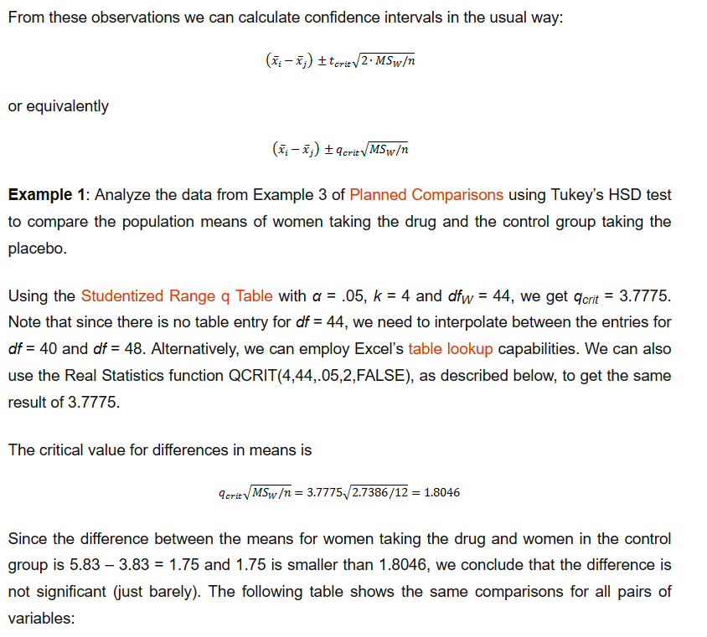

Tables can be found as:

<https://www.real-statistics.com/statistics-tables/studentized-range-q-table/>

or reproduced from SAS code:

**data** Tukey;

* to get the critical p-value for the Tukey test;

* use prob=0.90 to get the right-tail probability for 0.10 etc;

* nparms is number of groups , say k;

* df is degrees of freedom of the within-group variance from the anova;

* for equal sized groups of n, this is k*n -k;

* check: results agree with https://www.real-statistics.com/statistics-tables/studentized-range-q-table/;

* below example is from ...;

alpha=**0.05**

q=**.**; prob=**1**-alpha; df=**44**; nparms=**4**;

q_crit=probmc('range',q,prob,df,nparms);

**run**;

**proc** **print**;**run**;

*****************;

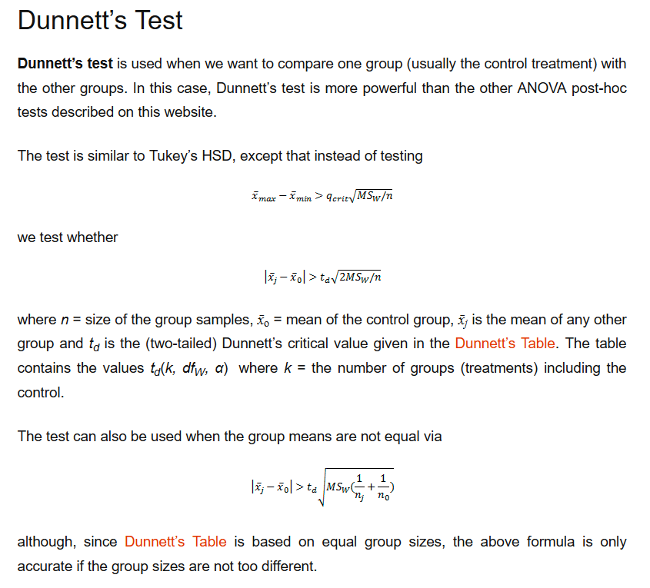

Dunnett’s test critical values: <https://www.real-statistics.com/statistics-tables/dunnetts-table/>

Or reproduced from (! nparms is now the number of groups **without** the control group)

**data** a;

* to get the critical p-value for the Dunnett's test;

* use prob=0.95 to get the right-tail probability for 0.05 etc;

* nparms is number of groups without the control group, k, so in total k+1 groups;

* df is degrees of freedom of the within-group variance from the anova;

* for equal sized groups of n, this is k*n -k;

* check: results agree with https://www.real-statistics.com/statistics-tables/studentized-range-q-table/;

* below example is from ...;

alpha=**0.05**;

q=**.**; prob=**1**-alpha; df=**28**; nparms=**3**;

t_d=probmc('Dunnett2',q,prob,df,nparms);

q_crit=sqrt(**2**)*t_d;

**run**;

**proc** **print**;**run**;